FILE Service1.svc

public List<ATT_Tip> GetTips()

{

List<ATT_Tip> details = null;

try

{

details = DataAccess.GetTips();

}

catch (Exception ex)

{

log4net.Config.XmlConfigurator.Configure();

log.Error(ex.ToString());

}

return details;

}

Another option to create table as a List

public List<ATT_Tip> GetTips()

{

List<ATT_Tip> details = new List<ATT_Tip>();

ATT_Tip One = new ATT_Tip();

One.TIP = “DSDSDS”;

One.Link = “adfddddd”;

Detail.Add(One);

return Detail;

}

File IService1.cs

Declare method en class interface IService

public interface IService1

{

[OperationContract(IsOneWay = false)]

List<ATT_Tip> GetTips ();

}

Declare class for Fields

[DataContract]

public class ATT_Tip

{

[DataMember]

public string TIP { get; set; }

[DataMember]

public string LINK { get; set; }

}

REBULD

In Test Program Update WebService Reference

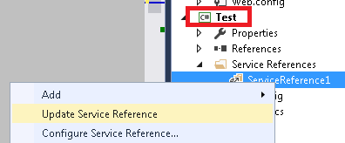

var site = RPA.ServiceLibrary.GetTips();

string ss = site[0].Link;